# CS 255 Business Requirements Document Template

Complete this template by replacing the bracketed text with the relevant information.

This template lays out all the different sections that you need to complete for Project One. Each section has guiding questions to prompt your thinking. These questions are meant to guide your initial responses to each area. You are encouraged to go beyond these questions using what you have learned in your readings. You will need to continually reference the interview transcript as you work to make sure that you are addressing your client’s needs. There is no required length for the final document. Instead, the goal is to complete each section based on your client’s needs.

**Tip:** You should respond to a bullet list for each section. This will make your thoughts easier to reference when you move into the design phase for Project Two. One starter bullet has been provided for you in each section, but you will need to add more.

## System Components and Design

### Purpose

*What is the purpose of this project? Who is the client and what do they want their system to be able to do?*

* The purpose of this project is to create a system for DriverPass that helps improve student pass rates on driving tests by offering both online practice exams and scheduled on-the-road lessons.
* DriverPass wants a system that is easy to use, secure, and provides students with helpful tools to prepare more effectively.
* The client is looking to streamline both the training and scheduling experience into one platform.

### System Background

*What does DriverPass want the system to do? What is the problem they want to fix? What are the different components needed for this system?*

* DriverPass noticed that many students fail their driving tests because they rely too heavily on memorizing practice questions.
* They want a system that offers a mixture of practical road training and online preparation to better equip students.
* The main components will include user management (for students, instructors, and admin), scheduling, progress tracking, payment processing, and a testing interface for online practice.

### Objectives and Goals

*What should this system be able to do when it is completed? What measurable tasks need to be included in the system design to achieve this?*

* The system should let students schedule lessons, take practice exams, and track their progress.
* Instructors should be able to view schedules, track student progress, and update training records.
* The administration should allow management of users, lessons, and reporting.
* The system should be secure, accessible, and functional on mobile and desktop devices.
* Measurable goals include successful account creation, practice test completion tracking, and driving lesson scheduling.

## Requirements

### Nonfunctional Requirements

*In this section, you will detail the different nonfunctional requirements for the DriverPass system. You will need to think about the different things that the system needs to function properly.*

#### Performance Requirements

*What environments (web-based, application, etc.) do this system need to run in? How fast should the system run? How often should the system be updated?*

* The system should be fully web-based and accessible on mobile browsers.
* Pages should be loaded within 2 seconds under normal network conditions.
* Real-time updates for scheduling should be supported.
* The platform will be updated monthly, with bug fixes applied as needed.

#### Platform Constraints

*What platforms (Windows, Unix, etc.) should the system run on? Does the back end require any tools, such as a database, to support this application?*

* The system should work on Windows, macOS, Android, and iOS platforms.
* The backend may use Node.js or similar tech, and a database such as Firebase or AWS RDS.
* The frontend could use a modern framework like React to keep things responsive.

#### Accuracy and Precision

*How will you distinguish between different users?* *Is the input case-sensitive? When should the system inform the admin of a problem?*

* Unique email addresses and usernames will identify users.
* Inputs like passwords and emails should be case-sensitive.
* The system should alert the admin when invalid data is submitted or when login attempts fail.

#### Adaptability

*Can you make changes to the user (add/remove/modify) without changing code? How will the system adapt to platform updates? What type of access does the IT admin need?*

* Admins should be able to add or remove users through the interface without needing code changes.
* The system should be adaptable to new features or future updates.
* IT admin access will allow for platform maintenance and user issue resolution.

#### Security

*What is required for the user to log in? How can you secure the connection or the data exchange between the client and the server? What should happen to the account if there is a “brute force” hacking attempt? What happens if the user forgets their password?*

* All users must log in using email and password credentials.
* Connections must be encrypted with HTTPS for secure data transfer.
* After five failed login attempts, accounts should temporarily lock.
* Users who forget passwords can reset them through secure email verification.

### Functional Requirements

*Using the information from the scenario, think about the different functions the system needs to provide. Each of your bullets should start with “The system shall . . .” For example, one functional requirement might be, “The system shall validate user credentials when logging in.”*

* The system allows users to register and log in securely.
* The system should let students take online practice tests and receive feedback.
* The system allows students to schedule, reschedule, or cancel on-the-road lessons.
* The system shall allow instructors to view schedules and input student progress updates.
* The system shall handle payment processing and display payment history.
* The system shall allow admins to manage users, view reports, and maintain lesson structures.

### User Interface

*What are the needs of the interface? Who are the different users for this interface? What will each user need to be able to do through the interface? How will the user interact with the interface (mobile, browser, etc.)?*

* The interface should be clean and simple, designed for both desktop and mobile use.
* Students will use it to register, take tests, schedule lessons, and view their progress.
* Instructors will use it to view their schedule and update records.
* Admins will manage accounts, update lesson info, and handle user support.
* The UI must be easy to navigate with clear labeling and helpful prompts.

### Assumptions

*What things were not specifically addressed in your design above? What assumptions are you making in your design about the users or the technology they have?*

* Users will have reliable internet access and access to a web browser.
* Users have basic computer and mobile device skills.
* Instructors will actively use the system to manage their student lessons.
* Most users will access the system via Chrome, Safari, or Firefox.

### Limitations

*Any system you build will naturally have limitations. What limitations do you see in your system design? What limitations do you have as far as resources, time, budget, or technology?*

* The system may be limited by budget and time, so some advanced features like live chat support or DMV integration may not be included right away.
* The first version will only support English.
* System support staff may be limited during early deployment.
* Compatibility with future OS updates will need to be tested over time.

### Gantt Chart

*Please include a screenshot of the GANTT chart that you created with Lucidchart. Be sure to check that it meets the plan described by the characters in the interview.*

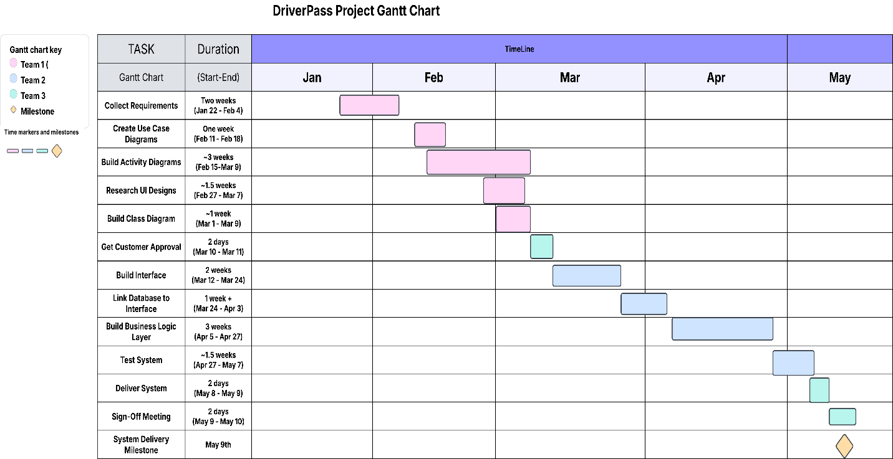

**References**

* Dennis, A., Wixom, B. H., & Roth, R. M. (2021). *Systems analysis and design* (7th ed.). Wiley.
* Hoffer, J. A., George, J. F., & Valacich, J. S. (2020). *Modern systems analysis and design* (10th ed.). Pearson.
* Kendall, K. E., & Kendall, J. E. (2011). *Systems analysis and design* (8th ed.). Pearson.
* Lucid Software. (n.d.). *Create professional diagrams with Lucidchart*. Lucidchart. <https://www.lucidchart.com>